CCT College Dublin

Assessment Cover Page

Module Title:

Assessment Title:

Lecturer Name:

Student Full Name: | Morgane Paula Tassoneiro
Student Number: | 2021327
Assessment Due Date: | 16/03/25
Date of Submission: | 00/03/25

Declaration

By submitting this assessment, I confirm that I have read the CCT policy on Academic Misconduct and understand the implications of submitting work that is not my own or does not appropriately reference material taken from a third party or other source. I declare it to be my own work and that all material from third parties has been appropriately referenced. I further confirm that this work has not previously been submitted for assessment by myself or someone else in CCT College Dublin or any other higher education institution.

Optimizing Wine Stock Management at Lotts & Co. Using Data Analytics

Table of Contents
1. Introduction
2. Business Case for Lotts & Co.
3. Business Analysis Method: SWOT Analysis

1. Introduction
Project Goal:
The whole purpose of this project entails using data analytics to optimize the wine stock management at Lotts & Co. so that best-sellers are always available while minimizing overstock on slow-moving wines.
Why This Matters:
Stock shortages lead to lost sales, while excess stock ties up cash flow and takes up valuable storage space. The idea behind this project is data-driven decision-making, which will help improve inventory management and supplier coordination.
Scope:
The study investigates the sales scenario of wine and forecasts the demand trends to ensure higher efficiency in stock replenishment besides pinpointing highly selling products and slow-moving ones.
Business Case for Lotts & Co.
2. Ensuring that high-demand wines are always in stock - Prevents lost sales and guarantees customer satisfaction and revenue increase. Research states that stock-outs cause potential sales losses of about 4% . (Corsten & Gruen, 2004)
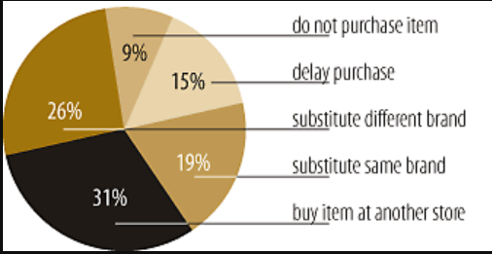
Figure 1: Harvard Business School Publishing, 2004
✅ Reducing excess inventory - Excess stock equates to unnecessary storage incurable costs. Data-based inventory control can minimize holding costs by almost 30% (Johnson & Outcalt, 2024).
✅ Demand trend forecasting - Anticipating seasonal demand peaks (like Christmas, and weekends) allows for timely stock replenishment. The celebration surges with alcohol consumption.
“Mitchells said that sales growth was strong during the key festive days, with record sales on Christmas.”
(Reuters, 2025)
✅ Optimize supplier coordination - Align stock orders in real-time with sales to avoid delays and improve order accuracy. Supplier analytics can empower companies to deliver 20% more efficiently and a 15% reduction in operational costs, making companies be more proactive with informed decisions. (North Bay Distribution, 2024)
3. Business Analysis Method: SWOT Analysis

References
Corsten, D., & Gruen, T. (2004, 05 01). Harvard Business Review. Retrieved 02 25, 2025, from Stock-Outs Cause Walkouts: https://hbr.org/2004/05/stock-outs-cause-walkouts
Johnson, P. M., & Outcalt, R. F. (2024). The Retail owners institute. Retrieved 02 25, 2025, from Why and How to Reduce the High Cost of Too Much Inventory: https://retailowner.com/Five-Steps-To-Financial-Strength/What-Do-I-Work-On-First/Inventory/Costs-of-Excess-Inventory?utm_source=chatgpt.com
North Bay Distribution. (2024, 08 29). North Bay Distribution INC. Retrieved 02 25, 2025, from Realizing Supply Chain Efficiency with Advanced Analytics: https://nbd3pl.com/fulfillment/realizing-supply-chain-efficiency-with-advanced-analytics/?utm_source=chatgpt.com
Reuters. (2025, 01 15). Reuters. Retrieved 02 25, 2025, from UK's Mitchells & Butlers posts higher sales during festive season: https://www.reuters.com/markets/europe/uks-mitchells-butlers-posts-higher-sales-during-festive-season-2025-01-15/?utm_source=chatgpt.com

